Presentation

Jeronimo needs to open his Burger Joint in some Locality (District) of Bogotá, Colombia. Furthermore, he is asking our assistance in finding the best Locality. Business Problem So as to open Jeronimo's burger joint, we will want to utilize some data about the Localities in Bogotá. We should be certain that where the burger joint is opened will have enough clients and furthermore that there aren't an enormous ammount of burer joints in the spot.

|  |
| --- |
| Information |
|  |  |
|  | To help Jeronimo in his hunt we should get to following information: |
|  |  |
|  | - The Localities of Bogotá, Colombia from Wikipedia: https://es.wikipedia.org/wiki/Anexo:Localidades_de_Bogot%C3%A1 |
|  |  |
|  | - The directions (scope, longitude) ot these Localities of Bogotá from Open Street Map APIs |
|  |  |
|  | - From Foursquare we will require following scenes information: |
|  |  |
|  | - the burger joint settings of the Localities |
|  |  |
|  | - the workplaces settings of the Localities |
|  |  |
|  | - the secondary schools settings of the Localities |
|  |  |
|  | - the colleges settings of the Localities |
|  |  |
|  | We will at that point influence the information so as to figure out which area is the most proper so as to find the burger joint. |

Methodology

• For each locality, all office, school, university and burger joints venues data have been collected from Foursquare.

• Then for each locality, the sums of the office, school, university and burger joints were computed.

• For each of this 4 categories, a weight (or penalty) has been defined according to what Jeronimo considers the most important.

• Burger Joints have been weighted with -1, since Paolo wants to avoid concurrence.

• Schools have been weighted with 1, since student are good customers.

• Universities have been weighted with 1.5, since students are good customers.

• Offices have been weighted with 2, since employees are even better customers.

• Note that the weights can be modified according to the importance of each category.

• Lastly, a score was computed for each locality as the weighted sum of the number of venues in each of the 4 categories (school, university, office, burger joints).

Coding

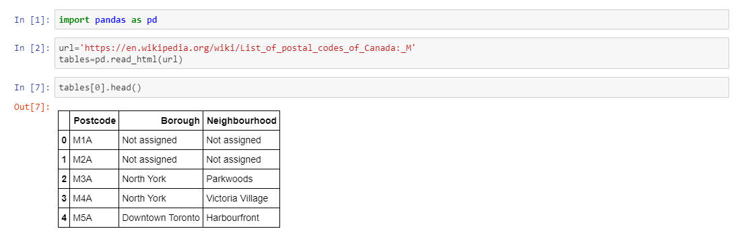

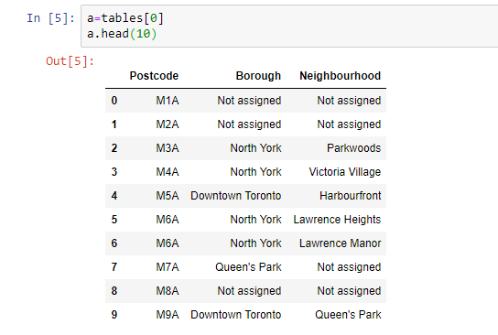

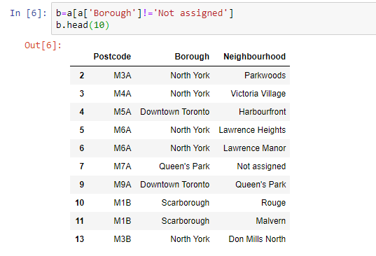

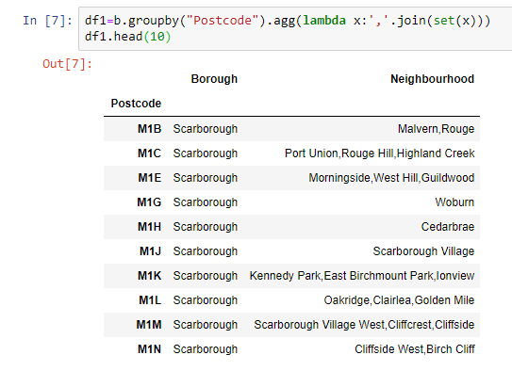

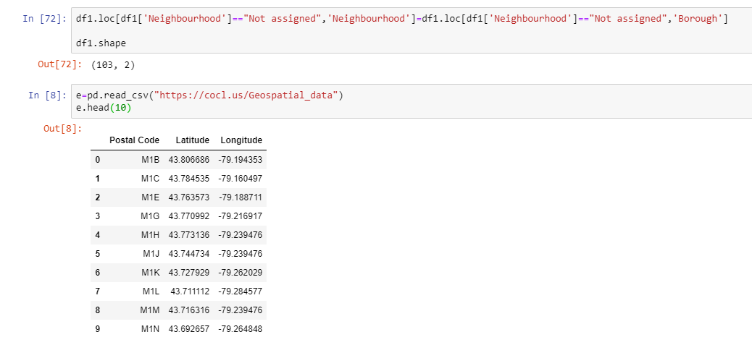

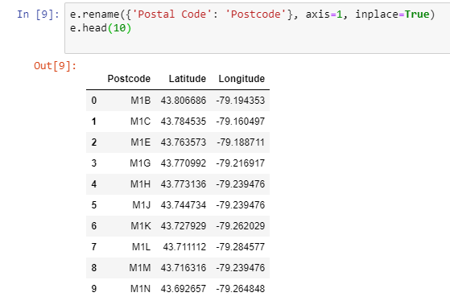

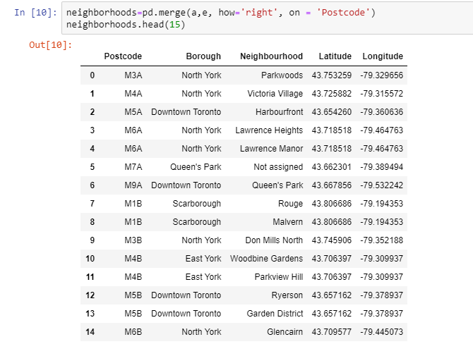

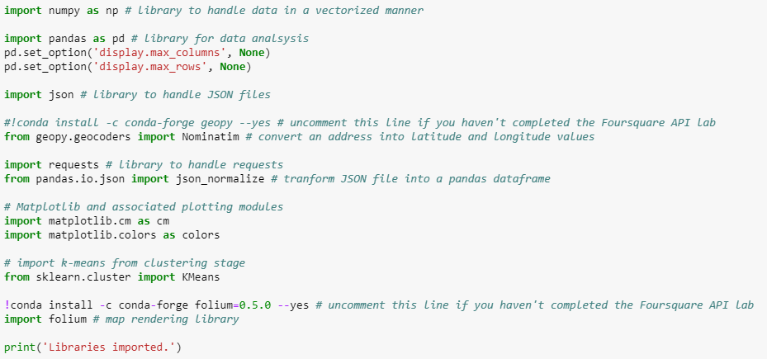

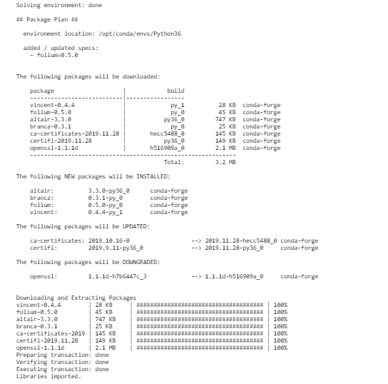

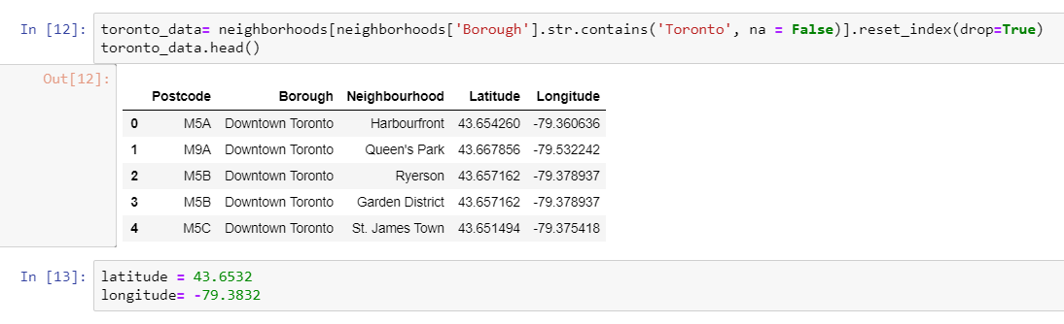

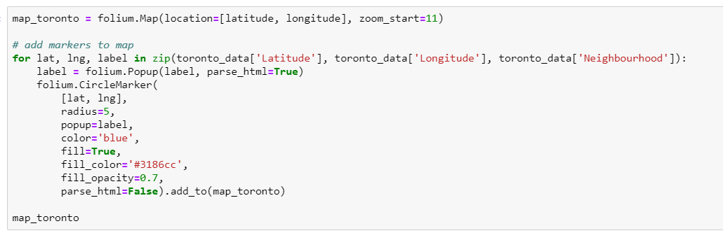

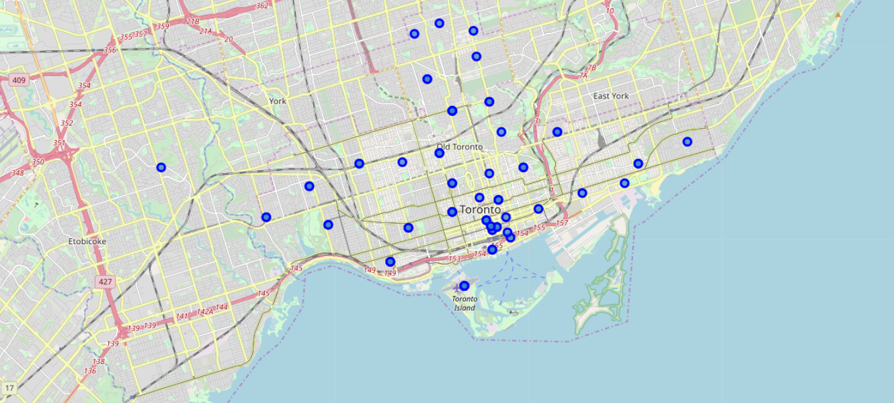

Recommendation

The following analysis can be improved with following extensions:

• Consider more categories. For example like "Night life" which is also a good source for customers. But also like "Restaurants", which even if not burger joints may be some concurrence if too many.

• In the Locality itself, it can also be computed the distance between all the venues in order to find a place with the most number of potential customers.

• Using smaller geographical areas like Neighborhoods could improve the accuracy for the scores.